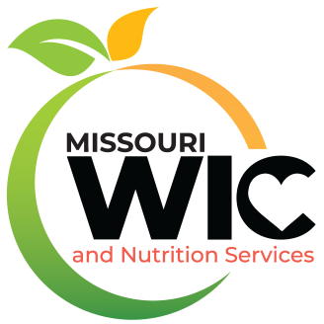
The Caldwell County Health Department has announced that a contract to continue to provide WIC services for federal fiscal year 2023 has been signed with the Missouri Department of Health and Senior Services. Under the terms of the contract, the Caldwell County Health Department will be able to serve approximately 344 persons eligible for WIC every month.
Women, Infants and Children (WIC) is a special supplemental nutrition program providing services to pregnant women, new mothers, infants and children up to their 5th birthday based on nutritional risk and income eligibility. The primary services provided are health screening, risk assessment, nutrition education and counseling, breastfeeding promotion and referrals to health care. Nutritious supplemental food is provided at no cost to participants. To be eligible for Missouri WIC applicants must have an income of less than or equal to 185% of the poverty level, reside in the state of Missouri and be determined by a health professional to be at nutritional risk. Migrant families are also eligible.
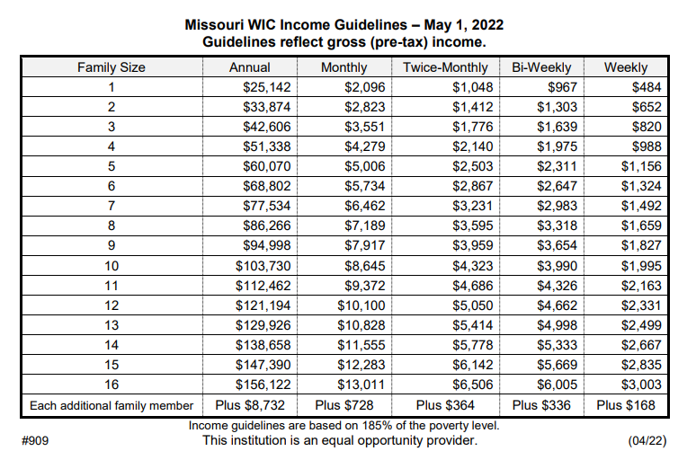

WIC supplemental food packages are specially chosen to provide foods high in protein, iron, calcium, and vitamins A and C. Eligible women and children receive fortified milk and cheese, eggs, whole grain bread products and hot or cold cereals, 100% fruit juices and fresh or frozen fruits and vegetables. The WIC program recommends breastfeeding, provides breastfeeding support, baby foods and infant cereal. For women who cannot or choose not to breastfeed, infants may receive supplemental iron fortified formula. WIC participants obtain their foods by using an eWIC card for specific items at local grocery stores and pharmacies.
Studies confirm that pregnant women who enroll in WIC during the early months of pregnancy have fewer low birth weight babies, experience fewer infant deaths, see the doctor earlier in pregnancy and eat healthier.
WIC is administered in Caldwell County by the Caldwell County Health Department. WIC Clinic days include:
Caldwell County Health Dept at 255 W Main, Kingston, MO 64650 on
The 1st Thursday of the month from 8am-12pm & 12:30pm-4:30pm
The 2nd Thursday of the month from 8am-12pm
The 3rd Thursday of the month from 8am-12pm

Lloyd Wallace Building at 217 N Main, Braymer, MO 64624
The 2nd Wednesday of the month from 1pm-4pm

Hamilton United Methodist Church at 104 W Samuel St, Hamilton, MO 64644
The 4th Wednesday of the month from 12pm-5pm

Polo Family Health Center at 101 Meadowbrook Lane, Polo, MO 64671
The last Friday of the month from 12pm-4pm

Those interested can call our office at 816-586-2311 to complete the pre-screening process and set-up an appointment.

Please click link for the Disclaimer & Non-Discrimination Statement:
https://health.mo.gov/living/families/wic/frauddatalinks/nondiscrimination/

